Functions and queries

1/05/2023

Q1) Write a query to show the category with the greatest number of books.

Ans.

SELECT CATEGORY, COUNT(CATEGORY) AS BOOK_COUNT

FROM LMS_BOOK_DETAILS

GROUP BY CATEGORY

HAVING COUNT(CATEGORY) = (SELECT Max(COUNT(CATEGORY)) FROM LMS_BOOK_DETAILS

GROUP BY CATEGORY)

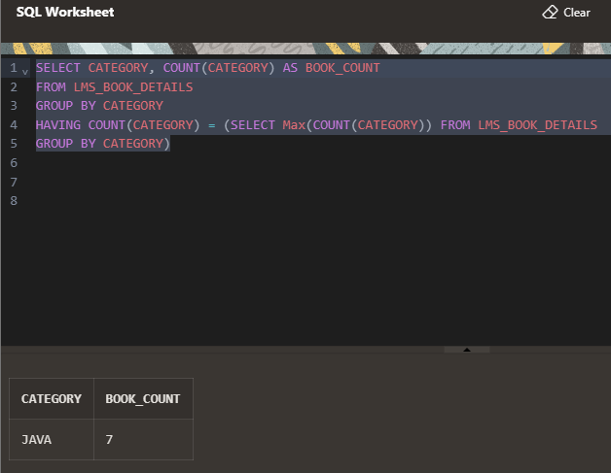

Q2) Write a query to show this output. List of the books that are

available in library and never issued (Hint : use join function and case

function)

Ans-Attempt 1

select *

from LMS_book_issue AS I

FULL OUTER join LMS_book_details AS D

ON I.MEMBER_ID = D.MEMBER_ID;

ATTEMPT 2

SELECT *

FROM LMS_book_issue AS I

FULL OUTER JOIN LMS_book_details AS D

ON I.MEMBER_ID = D.MEMBER_ID

where I.DATE_ISSUE IS NULL;

attempt 3

Select * from LMS_book_issue

full outer join LMS_book_details

on LMS_book_issue.MEMBER_ID = LMS_book_details.MEMBER_ID

where LMS_book_issue.DATE_ISSUE IS null

and LMS_book_issue.BOOK_CODE IS not null;

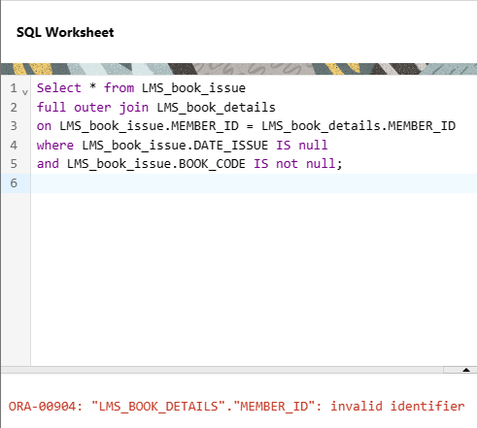

Attempt 4

SELECT *

FROM LMS_book_issue

FULL OUTER JOIN LMS_book_details

ON LMS_book_issue.BOOK_CODE = LMS_book_details.BOOK_CODE

WHERE LMS_book_issue.DATE_ISSUE IS NULL

AND LMS_book_issue.BOOK_CODE IS NOT NULL;

SELECT *

FROM LMS_book_issue;

select * from

LMS_book_details;

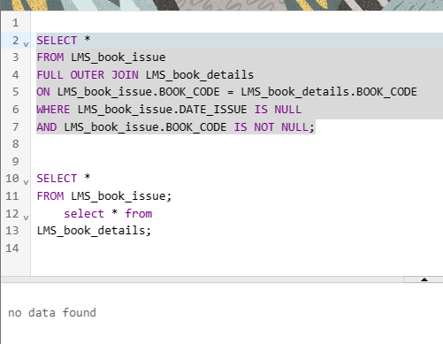

Attempt 5.

SELECT LMS_book_details.BOOK_TITLE,

CASE

WHEN LMS_book_issue.BOOK_CODE IS NULL THEN 'Available'

ELSE 'Not Available'

END AS STATUS

FROM LMS_book_details

LEFT JOIN LMS_book_issue

ON LMS_book_details.BOOK_CODE = LMS_book_issue.BOOK_CODE

WHERE LMS_book_issue.BOOK_CODE IS NULL;

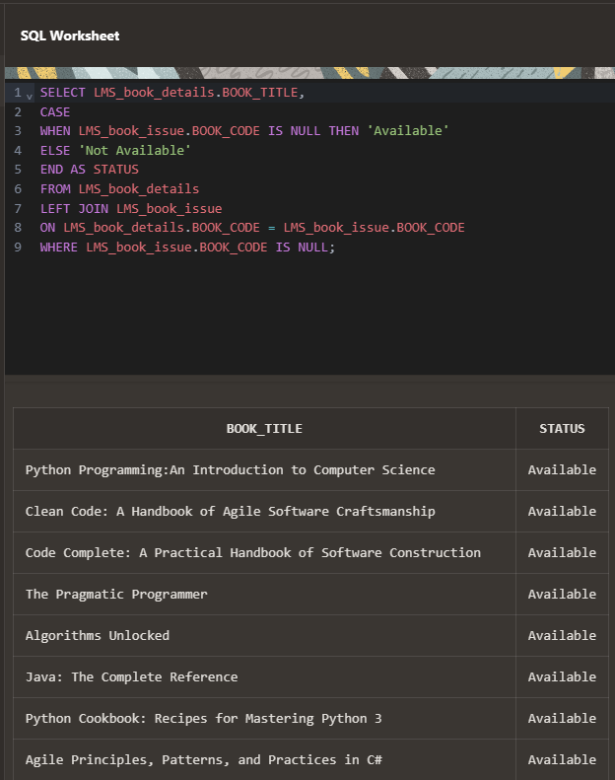

Q3) Write queries to get output as per required:

i) Write a query to count the number of permanent members vs

temporary members.

method

Ans.

method 1.

SELECT MEMBERSHIP_STATUS, COUNT(*) AS COUNT

FROM LMS_MEMBERS

GROUP BY MEMBERSHIP_STATUS;

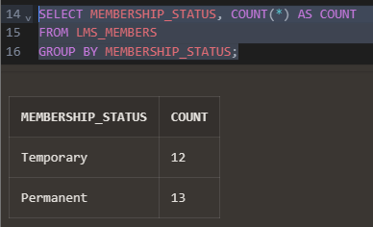

Method 2.

SELECT

SUM(CASE WHEN MEMBERSHIP_STATUS = 'Temporary' THEN 1 ELSE 0 END) AS Temporary,

SUM(CASE WHEN MEMBERSHIP_STATUS = 'Permanent' THEN 1 ELSE 0 END) AS Permanent

FROM LMS_MEMBERS;

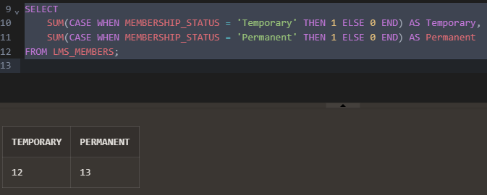

ii) Write a query to display the average price of different book

categories.

Ans.

SELECT CATEGORY, AVG(PRICE) AS AVG_PRICE

FROM LMS_BOOK_DETAILS

GROUP BY CATEGORY;

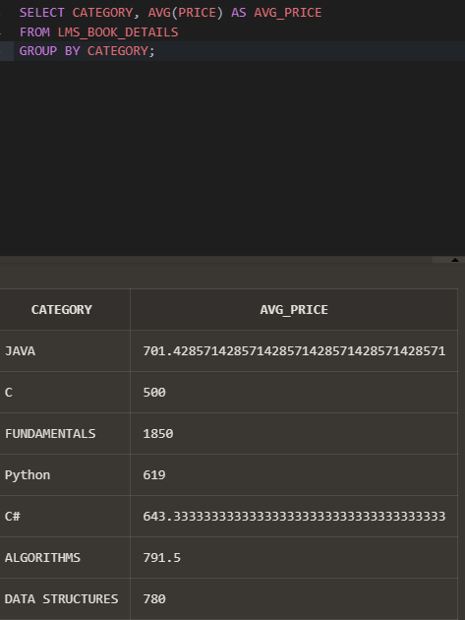

Note

round comes first and then avg

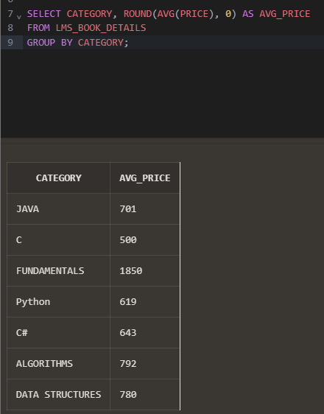

iii) Write a query to display the total fine amount paid by all

members

Ans-

SELECT SUM(FINE_AMOUNT) AS total_fine_amoun FROM LMS_FINE_DETAILS;

